Use Cases and Logical Architecture

* XID: X00118478
* Name: Alex Mac Uaid
* Project Title: Traffic Analysis System

## Section 1: For Each Use Case:

|  |  |
| --- | --- |
| Use Case ID | 001 |
| Title (goal) | Login to the Analysis System |
| Primary Actor | Officer, Admin |
| Story | The officer or Admin will open the Application. Once opened the Officer / Admin will then be prompted to enter their username and password. |
| Pre-Condition | Username and password exist in the database, which allows the actor to login. |
| Basic Flow | On submission of a successful username and password the application will then progress to the dashboard. |
| Alternative Flow | On Submission of an incorrect username and password the application will prompt the user that the username or password is incorrect and encourage them to try again. |

|  |  |
| --- | --- |
| Use Case ID | 002 |
| Title (goal) | Create account on the Analysis System |
| Primary Actor | Officer, Admin |
| Story | The officer or Admin will open the Application. Once opened the Officer / Admin will then be prompted to enter their username and password or have the option to create an account.  All fields will be mandatory  The account application will have the following form:   * First Name * Last Name * Date of Birth * Area of Work * Username * Password * Password Confirmation * Email   On page two the application will then request the user to verify their email. |
| Pre-Condition |  |
| Basic Flow | On submission of a successful application for an account, the application will request the email be verified by entering a code which is sent directly to the user. On submission of the correct code then progress to the dashboard. |
| Alternative Flow | On Submission of an incorrect criteria the application will highlight the fields and notify the user that the fields are a requirement.  If the email is not verified within 10 minutes the created application should get automatically deleted.  If the Username entered or email entered exists in the database, a notification will be displayed informing the actor that the information already exists. |

|  |  |
| --- | --- |
| Use Case ID | 003 |
| Title (goal) | Utilise Analytical Dashboard on Analysis System |
| Primary Actor | Officer, Admin |
| Story | The Main page “Home-Page” of the application will allow a logged in user to view the Dashboard.  The Analytical Dashboard will display operational and strategic data. The Dashboard will offer drill-down functionality.  Dashboard should display:   * Traffic Status Meter – (Heavy, Average, Clear). * Team members can view or hide daily tasks. * Camera Status * Statistics & Data Visualisation * Live View |
| Pre-Condition | Successful Login |
| Basic Flow | The user will have the capability of viewing the above display and have the drill-down functionality available for them. |
| Alternative Flow |  |

|  |  |
| --- | --- |
| Use Case ID | 004 |
| Title (goal) | View Website Portal |
| Primary Actor | Officer, Admin, Public |
| Story | The website portal will allow access to all. The website will have the following pages:   * Home * About * Services * Downloads * Contact |
| Pre-Condition |  |
| Basic Flow | All users will have access to the website pages and can navigate freely through the website. |
| Alternative Flow |  |

|  |  |
| --- | --- |
| Use Case ID | 005 |
| Title (goal) | View Website Portal (Homepage) |
| Primary Actor | Officer, Admin, Public |
| Story | The website portal (Homepage) will have the following:   * Company Logo * Brief Description * Traffic Status * Portal to enter the application. * Weather conditions |
| Pre-Condition |  |
| Basic Flow |  |
| Alternative Flow |  |

|  |  |
| --- | --- |
| Use Case ID | 006 |
| Title (goal) | View Website Portal (About) |
| Primary Actor | Officer, Admin, Public |
| Story | The user can view the about page via the Tab on the menu of the Website. About will describe the goals of the project. |
| Pre-Condition |  |
| Basic Flow |  |
| Alternative Flow |  |

|  |  |
| --- | --- |
| Use Case ID | 007 |
| Title (goal) | View Website Portal (Services) |
| Primary Actor | Officer, Admin, Public |
| Story | The user can view what services are available via the website services page. When they click the link for the system they will enter the application and will be prompted to enter their login details. |
| Pre-Condition |  |
| Basic Flow |  |
| Alternative Flow |  |

|  |  |
| --- | --- |
| Use Case ID | 008 |
| Title (goal) | View Website Portal (Downloads) |
| Primary Actor | Officer, Admin, Public |
| Story | The user can view what Downloads are available via the website Download page. The download will present the user with Datasets which are created by the application and will be available to download which might aid navigational products like Google Maps in predicating how long a journey would take with heavy traffic. |
| Pre-Condition |  |
| Basic Flow |  |
| Alternative Flow |  |

|  |  |
| --- | --- |
| Use Case ID | 009 |
| Title (goal) | View Website Portal (Contact) |
| Primary Actor | Officer, Admin, Public |
| Story | This will be a generic contact form which requests:   * First name -required field * Last Name -required field * Email -required field * Phone * Message -required field |
| Pre-Condition |  |
| Basic Flow |  |
| Alternative Flow |  |

|  |  |
| --- | --- |
| Use Case ID | 010 |
| Title (goal) | Identify automobile |
| Primary Actor | Developer |
| Story | The application is required to Identify a type of car i.e. Car, Truck, Van, Bike. |
| Pre-Condition |  |
| Basic Flow |  |
| Alternative Flow |  |

|  |  |
| --- | --- |
| Use Case ID | 011 |
| Title (goal) | Server |
| Primary Actor | Developer |
| Story | Work on Server to connect the elements to one another. |
| Pre-Condition |  |
| Basic Flow |  |
| Alternative Flow |  |

|  |  |
| --- | --- |
| Use Case ID | 012 |
| Title (goal) | Identify speed of automobile |
| Primary Actor | Developer |
| Story | The application is required to perform an analysis on the speed of the vehicle.  When there is a change in speed as in if cars start travelling slower or stop completely then the user should receive a notification also the website should be updated to traffic is heavy. |
| Pre-Condition |  |
| Basic Flow |  |
| Alternative Flow |  |

## Section 2: Prototype Schedule, Winter Semester 2017

|  |  |
| --- | --- |
| Iteration #1, Complete 25/10/2017 |  |
| Iteration #2 Complete 15/11/2017 |  |
| Iteration #3 Complete 13/12/2017 |  |

## Section 3: Logical Architecture

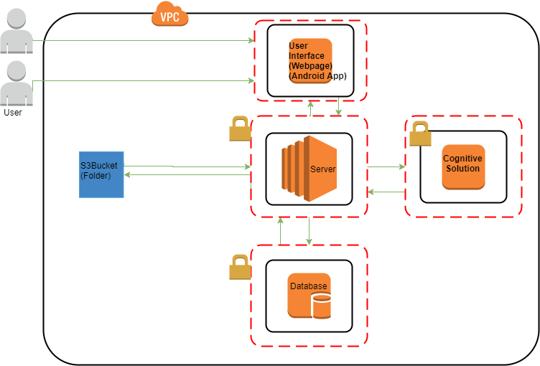

## Logical Architecture Discussion

1. The picture appears in the S3Bucket folder after being taken from the remote Internet Protocol camera. The image should be identified by the time stamp on which it was taken.
2. The server monitors the folder and then takes the picture with its timestamp and sends to cognitive solution. Detects the vehicles.
3. Cognitive solution performs an analysis on the image and detects the type of vehicle. Send back to the server the type and time.
4. The Server then sends the Type and timestamp to the storage in the Database.
5. Speed is then worked out in the application by accessing the database via the server.
6. Results are displayed in the drill down dashboard option in the User Interface.
7. Website is updated with traffic status.
8. When Traffic is heavy the threshold alarm goes off and notifies the users.